MID-TERM REPORT ON
VIRTUAL LABORATORY

UNDER THE GUIDANCE OF
Dr. Ramancherla Pradeep Kumar
Head, EERC, IIIT-HYD.

SUBMITTED BY
T.VENKAT DAS
Roll no: 200911013
M.Tech (CASE)



INTERNATIONAL INSTITUTE OF INFORMATION TECHNOLOGY
HYDERABAD

BASIC STRUCTRAL ANALYSIS

Contents:-
Basic structural analysis Pg.No
1) Stability of Columns
2) Bending Behaviour of beams
3) Behaviour of continuous beams

1. STABILITY OF COLUMNS

INTRODUCTION:
Structural members that support compressive axial loads are called Columns. A column in structural engineering is a vertical structural element that transmits, through compression, the weight of the structure above to other structural elements below
OBJECTIVE:
To determine the Column stability using boundary conditions.
THEORY:
In general if a beam element is under a compressive load and its length is an order of magnitude larger than either of its other dimensions such a beam is called columns. Due to its size its axial displacement is going to be very small compared to its lateral deflection called buckling.

The loads that are coming to column are more than the weight of the column the buckling factor takes place. A column can either fail due to the material yielding, or because the column buckles, it is of interest to the engineer to determine when this point of transition occurs.
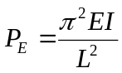Consider the Euler buckling equation

Here L=Length of the Column (ft)
E=Young’s Modulus (Ksi)
I=Moment of Inertia (mm^4)
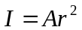Because of the large deflection caused by buckling, the least moment of inertia I can be expressed as
A is the cross sectional area
R is the radius of gyration.
The critical loads for the different sections given by
- Pinned-Pinned column buckling load for Length L=L
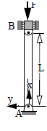
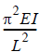

- Fixed-Fixed column buckling load for length L=(L/2)^2

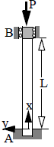
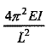

- Fixed-Pinned column buckling load for length L=(L/√2)^2
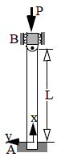
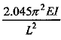

4) Fixed-Free column buckling load for length L= (L/2L) ^2

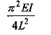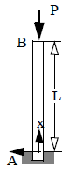

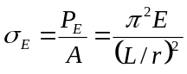Critical Column Stress:
Dividing the buckling equation by A, gives
σ_{E} is the compressive stress in the column and must not exceed the yield stress σ_{Y} of the material, i.e. σ_{E}<σ_{Y}, L / r is called the slenderness ratio, it is a measure of the column's flexibility
Critical Buckling Load:
P_{crit} is the critical or maximum axial load on the column just before it begins to buckle E Young’s modulus of elasticity
I least moment of inertia for the columns cross sectional area .
L unsupported length of the column whose ends are pinned

Input values given based on the condition:
1) young’s modulus :___________( ksi)
2) Area moment of inertia (I) _________ (mm^4)
3) Length of column (L) ___________ (ft)
4) Boundary conditions

OBSERVATION:-
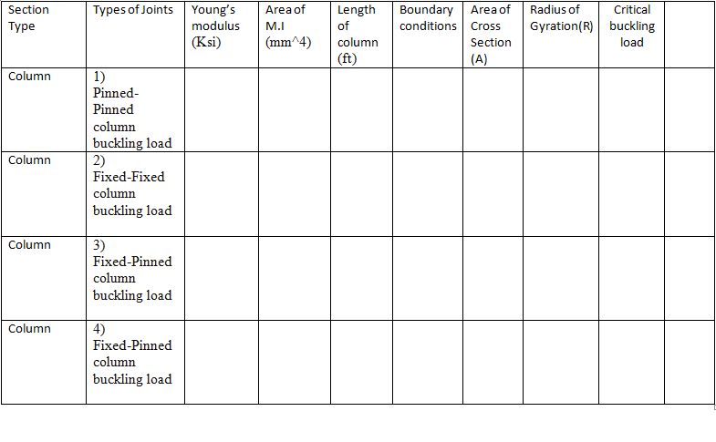

Quiz:
- The buckling load formula for column?
- Number of boundary conditions that are present in columns
- What are the constant values that doesn’t change in calculation of Pcr

References:
Mechanics of materials by Dr.B.C.punmia
Stability of columns by YI Nagornyi Prof
Design of steel structures by Prof.S.R.Satish Kumar and Prof A.R.Santha Kumar

2. DEFLECTION OF BEAMS

INTRODUCTION:
A beam is a structural element that is capable of withstanding load primarily by resisting bending. The bending force induced into the material of the beam as a result of the external loads, own weight and external reactions to these loads is called a bending moment. Beams generally carry vertical gravitational forces but can also be used to carry horizontal loads (i.e., loads due to an earthquake or wind). The loads carried by a beam are transferred to columns, walls, or girders, which then transfer the force to adjacent structural compression members. In Light frame construction the joists rest on the beam.
Beams are characterized by their profile (the shape of their cross-section), their length, and their material. In contemporary construction, beams are typically made of steel, reinforced concrete, or wood. One of the most common types of steel beam is the I-beam or wide-flange beam (also known as a "universal beam" or, for stouter sections, a "universal column"). This is commonly used in steel-frame buildings and bridges. Other common beam profiles are the C-channel, the hollow structural section beam, the pipe, and the angle.

OBJECTIVE:
To Study the beam under different loads acting on it.
THEORY:
In General when the beam is subject to the loading on it deflects and some of the moments and reactions occur in that beam. By determining the loads and member at particular distance the bending moment and shear force can be known.
Shear Force: Shear force is an internal force in any material which is usually caused by any external force acting tangent (perpendicular) to the material, or a force which has a component acting tangent to the material.
Bending Moment: Bending moment is the algebraic sum of moments to the left or right of the section. In each case, by considering, either for forces or moments the resultants caused by applied forces to one side of the section is balanced by bending moment and shear force acting on the section.

A beam with a moment of inertia I and with Young's modulus E will have a bending stress f at a distance from the Neutral Axis (NA) y and the NA will bend to a radius R ...in accordance with the following formula.

M / I = σ / y = E / R

Simply Supported Beam. Concentrated Load

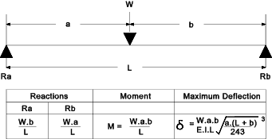

Simply Supported Beam. Uniformly Distributed Load
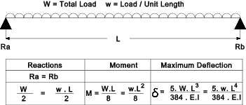

Cantilever. Concentrated Load
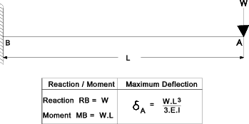

Cantilever. Uniformly Distributed Load
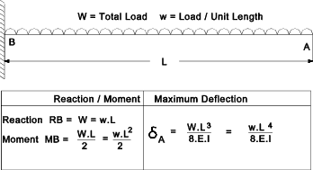
Fixed Beam. Concentrated Load

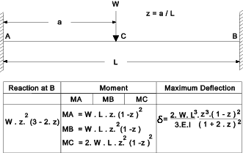

Fixed Beam. Uniformly Distributed Load
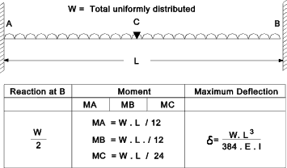

SNAP SHOTS:
The snap shots that are hand written those are
1. Simply Supported
2. Fixed beams
3. Cantilever

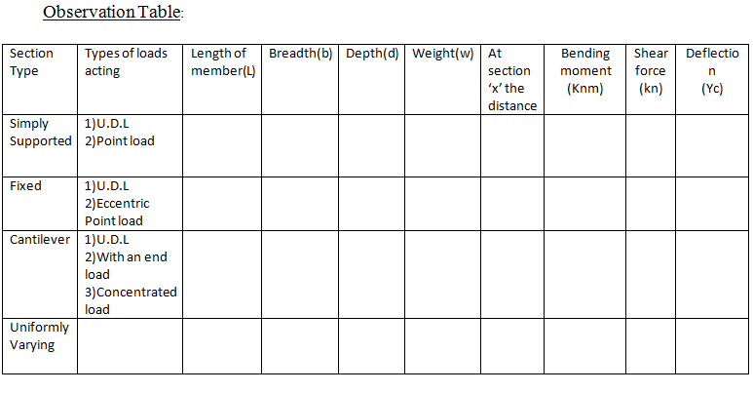

Output:
1. Bending moment________ (Knm)
2. Shear Force_________ (KN)
3 Deflections_________ (Yc)

QUIZ:
- What is a beam?
- What is point of inflection?
- What is Young’s modulus?
- What is the maximum deflection of a S.S. beam when point load is applied at the center?
- Bending moment profile for a S.S. beam under U.D.L is parabolic. (T/F)
- The ratio of change in length to the original length is ___________.
- Tension occurs at bottom of the cantilever beam when point load is applied at the center. (T/F)

REFERENCES:
1 .Theory of structures Volume: 1 by S.P.Gupta and G.S.Pandit
2. Reference from √X MATHalino.Com
3. Mechanics of Materials by B.C.Punmia

3. BEHAVIOUR OF CONTINOUS BEAMS

INTRODUCTION:
Continuous beams, which are beams with more than two supports and covering more than one span, are not statically determinate using the static equilibrium laws
e = strain
σ = stress (N/m²)
E = Young's Modulus = σ /e (N/m²)
y = distance of surface from neutral surface (m).
R = Radius of neutral axis (m).
I = Moment of Inertia (m⁴ - more normally cm⁴)
Z = section modulus = I/y _{max}(m³ - more normally cm³)
M = Moment (Nm)
w = Distributed load on beam (kg/m) or (N/m as force units)
W = total load on beam (kg ) or (N as force units)
F= Concentrated force on beam (N)
L = length of beam (m)
x = distance along beam (m)

OBJECTIVE:
To find the shear force diagram and bending moment diagram for a given continuous beam.

THEORY:
Beams placed on more than 2 supports are called continuous beams. Continuous beams are used when the span of the beam is very large, deflection under each rigid support will be equal zero.
BMD for Continuous beams:
BMD for continuous beams can be obtained by superimposing the fixed end moments diagram over the free bending moment diagram.

Three - moment Equation for continuous beams THREE MOMENT EQUATION
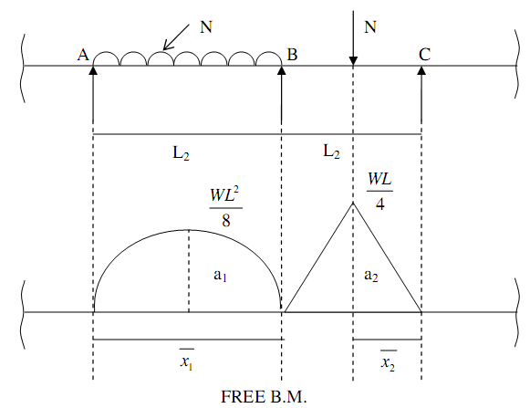
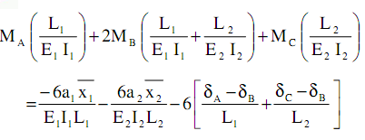
The above equation is called generalized 3-moments Equation.
MA, MB and MC are support moments E1, E2 → Young’s modulus of Elasticity of 2
Spans.

I1, I2 → M O I of 2 spans,

a1, a2 → Areas of free B.M.D.

1 2 x and x → Distance of free B.M.D. from the end supports, or outer supports.
(A and C)

δA, δB and δC → are sinking or settlements of support from their initial position.
Normally Young’s modulus of Elasticity will be same throughout than the
Equation reduces to
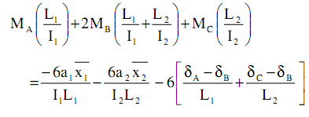
If the supports are rigid then δA = δB = δC = 0
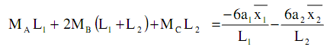
Note:

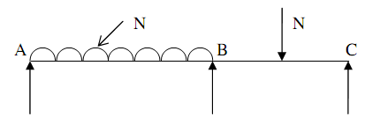
If the end supports are simple supports then M_{A} = M_{C} = 0.

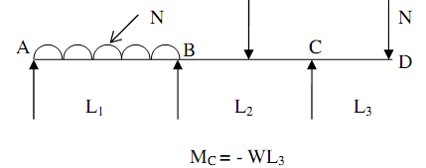
If three is overhang portion then support moment near the overhang can be
Computed directly.

3.
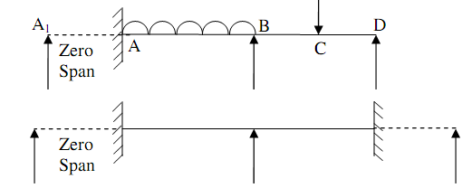
If the end supports are fixed assume an extended span of zero length and apply
3- Moment equation.
NOTE:
i)
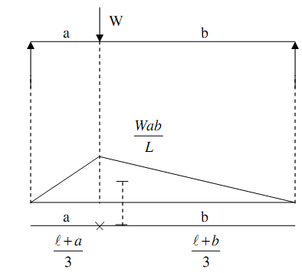
In this case centroid lies as shown in the figure.
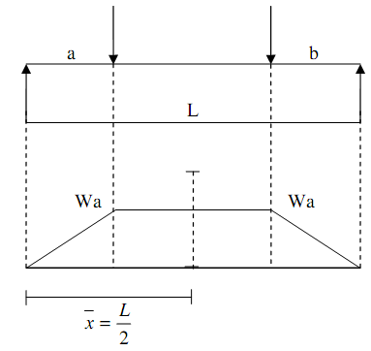
Observation Table:
Section type | Types  of loads | Length of member  (L) | Breadth(b) | Depth(d) | Weight  (W) | At a distance from section ‘X’ | Bending Moment  (Knm) | S.F  (Kn) | Deflection(Delta)
continuo’s  beams | Two Equal Spans – Uniform Load on One Span
Two Equal Spans – Concentrated Load at Center
of One Span
Two Equal Spans – Concentrated Load at Any
Point
 | Two Equal Spans – Uniformly Distributed Load
Two Equal Spans – Two Equal Concentrated Loads
Symmetrically Placed
 | Two Unequal Spans – Uniformly Distributed Load
Two Unequal Spans – Concentrated Load on Each
Span Symmetrically Placed

Output:
1. Bending moment________ (Knm)
2. Shear Force_________ (KN)
3 Deflections_________ (Yc)
References:
1. Theory of Structures volume: 1 by S.P.Guptha and G.S.Pandit
2. Reference taken from N.D.S.

